

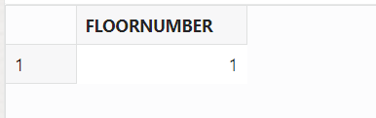

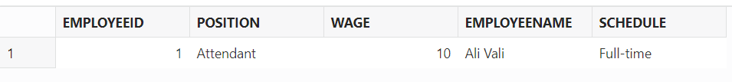

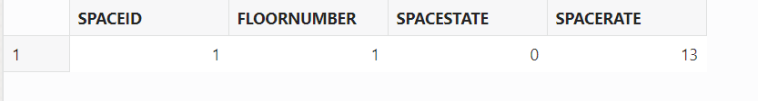

  
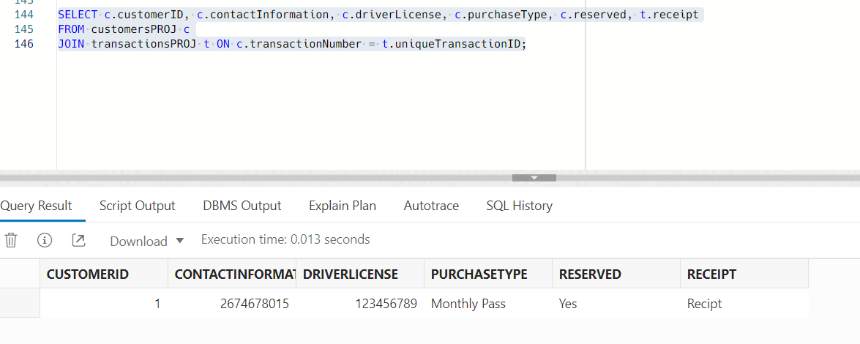  
  
  
CREATE DIRECTORY data_dir AS 'pathForFiles';

CREATE TABLE ext_customers

(

customerID NUMBER,

contactInformation NUMBER,

driverLicense NUMBER,

transactionNumber NUMBER,

purchaseType VARCHAR2(100),

reserved VARCHAR2(100),

spaceState VARCHAR2(100)

)

ORGANIZATION EXTERNAL

(

TYPE ORACLE_LOADER

DEFAULT DIRECTORY data_dir

ACCESS PARAMETERS

(

RECORDS DELIMITED BY NEWLINE

FIELDS TERMINATED BY ','

MISSING FIELD VALUES ARE NULL

)

LOCATION ('customers.csv')

)

REJECT LIMIT UNLIMITED;

INSERT INTO customersPROJ

SELECT * FROM ext_customers;

CREATE DIRECTORY data_dir AS 'pathForFiles';

CREATE TABLE ext_transactions

(

uniqueTransactionID NUMBER,

entryTime VARCHAR2(100),

entryDate DATE,

exitTime VARCHAR2(100),

exitDate DATE,

durationOfStay FLOAT,

totalTimeParkedCost NUMBER,

receipt VARCHAR2(100),

spaceID NUMBER,

employeeID NUMBER

)

ORGANIZATION EXTERNAL

(

TYPE ORACLE_LOADER

DEFAULT DIRECTORY data_dir

ACCESS PARAMETERS

(

RECORDS DELIMITED BY NEWLINE

FIELDS TERMINATED BY ','

MISSING FIELD VALUES ARE NULL

(

entryDate CHAR DATE_FORMAT DATE MASK "DD-MON-YYYY",

exitDate CHAR DATE_FORMAT DATE MASK "DD-MON-YYYY"

)

)

LOCATION ('transactions.csv')

)

REJECT LIMIT UNLIMITED;

INSERT INTO transactionsPROJ

SELECT uniqueTransactionID, entryTime, entryDate, exitTime, exitDate, durationOfStay, totalTimeParkedCost, receipt, spaceID, employeeID

FROM ext_transactions;

CREATE DIRECTORY data_dir AS 'pathForFiles';

CREATE TABLE ext_employees

(

employeeID NUMBER,

position VARCHAR2(100),

wage FLOAT,

employeeName VARCHAR2(100),

schedule VARCHAR2(100)

)

ORGANIZATION EXTERNAL

(

TYPE ORACLE_LOADER

DEFAULT DIRECTORY data_dir

ACCESS PARAMETERS

(

RECORDS DELIMITED BY NEWLINE

FIELDS TERMINATED BY ','

MISSING FIELD VALUES ARE NULL

)

LOCATION ('employees.csv')

)

REJECT LIMIT UNLIMITED;

INSERT INTO employeesPROJ

SELECT employeeID, position, wage, employeeName, schedule

FROM ext_employees;

CREATE DIRECTORY data_dir AS 'pathForFiles';

CREATE TABLE ext_parking_spaces

(

spaceID NUMBER,

floorNumber NUMBER,

spacesEmpty NUMBER,

spacesTaken NUMBER,

spaceRate NUMBER

)

ORGANIZATION EXTERNAL

(

TYPE ORACLE_LOADER

DEFAULT DIRECTORY data_dir

ACCESS PARAMETERS

(

RECORDS DELIMITED BY NEWLINE

FIELDS TERMINATED BY ','

MISSING FIELD VALUES ARE NULL

)

LOCATION ('parking_spaces.csv')

)

REJECT LIMIT UNLIMITED;

INSERT INTO parkingSpacesPROJ

SELECT spaceID, floorNumber, spaceState, spaceRate

FROM ext_parking_spaces;

INSERT INTO floorsPROJ (floorNumber)

VALUES (1);

INSERT INTO customersPROJ (customerID, contactInformation, driverLicense, transactionNumber, purchaseType, reserved, spaceState)

VALUES (1, 2674678015, 123456789, 1, 'Monthly Pass', 'Yes', 'Open');

INSERT INTO employeesPROJ (employeeID, position, wage, employeeName, schedule)

VALUES (1, 'Attendant', 10.50, 'Ali Vali', 'Full-time');

INSERT INTO parkingSpacesPROJ (spaceID, floorNumber, spaceState, spaceRate)

VALUES (1, 1, 0, 12.99); --0 is false, 1 is true, the bool var wasnt working for me

INSERT INTO transactionsPROJ (uniqueTransactionID, entryTime, entryDate, exitTime, exitDate, durationOfStay, totalTimeParkedCost, receipt, spaceID, employeeID)

VALUES (1, '09:00 AM', TO_DATE('2023-04-14', 'YYYY-MM-DD'), '11:30 AM', TO_DATE('2023-04-14', 'YYYY-MM-DD'), 2.5, 32.47, 'Recipt', 1, 1);

SELECT * FROM customersPROJ;

SELECT * FROM floorsPROJ;

SELECT * FROM employeesPROJ;

SELECT * FROM parkingSpacesPROJ;

SELECT * FROM transactionsPROJ;

SELECT c.customerID, c.contactInformation, c.driverLicense, c.purchaseType, c.reserved, t.receipt

FROM customersPROJ c

JOIN transactionsPROJ t ON c.transactionNumber = t.uniqueTransactionID;